A
PROJECT REPORT
ON
“EMPLOYEE AND NETWORK MONITOR SYSTEM”
SUBMITTED TO THE BOARD OF TECHNICAL EDUCATION
(MSBTE), MUMBAI

BY
Yogeshwar P. Kulkarni
Eknath P. Jadhav



DEPARTMENT OF COMPUTER TECHNOLOGY
BRAHMA VALLEY POLYTECHNIC
ANJANERI
NASIK

YEAR 2009-10

BRAHMA VALLEY POLYTECHNIC
ANJANERI NASIK

CERTIFICATE

This is to certify that

Yogeshwar P. Kulkarni
Eknath P. Jadhav

Have Submitted Partial Project Report On

EMPLOYEE AND NETWORK MONITOR SYSTEM

Towards the Partial Fulfilment of Final year of
Diploma in Computer Technology
During Academic Year 2009 – 2010

Prof.G.Gaikwad Prof.G.G.Kunde Prof. Prof.C.K.Patil
Project Guide H.O.D External Examiner Principal

DISSERTATION APPROVAL SHEET

A
Project
On
“EMPLOYEE AND NETWORK MONITOR SYSTEM”
Has successfully completed by
“Yogeshwar P. Kulkarni”
“Eknath P. Jadhav”

at
DEPARTMENT OF COMPUTER TECHNOLOGY
BRAHMA VALLEY POLYTECHNIC
ANJANERI
NASIK

YEAR 2009-2010

Prof.G.Gaikwad Prof. Kunde G.G.
Project Guide Head,
Computer Technology. Computer Technology.

Acknowledgement

A successful project work is the result of teamwork, which contains not only the people who contribute their logic and coding efforts, but also those who guide them. It gives us great pleasure in expressing our sincere gratitude and appreciation to all those who have been instrumental in the successful completion of the project.

Today we are very pleased as we are presenting the project report on “EMPLOYEE AND NETWORK MONITOR SYSTEM”.

We hereby take opportunity to regard our sincere thanks to the internal guide for his kind co-operation during the project. His efforts have been monumental in the completion of this project. He has been very generous with his advice, views and ideas and always ensured that we are on the right track.

Last but not least, we owe a word of thanks to all our friends, colleagues who helped us a lot throughout the year. It is their support, cheerfulness, encouragement and helping nature without which our project might not have been completed.

Finally hearty thanks and sorry to all of them who are related any how with my project, but I forget them in this havoc.

ABSTRACT

Do all your employees use their computer resources and Internet connection solely for your business? Do they work as hard when you are away as they do when you are watching over their shoulders? In other words, do you suspect your employee's productivity is lacking? You should consider installing a surveillance system to address the problem.

For this purpose, employee don’t take interest in the work, miss use of resources and wastage of time due to this organization get affected by financially and reputationaly.

To stop this activity we have develop this software which will monitor employee’s computers.

Look no further! Network and Employee Monitoring Software records and monitors your employee's activities and provides you on-site and remote access to computer screens in real time. The software-only solution can be installed in a matter of minutes, and does not require any hardware other than an ordinary PC. No special surveillance skills or security training are needed to successfully configure and operate Network and Employee Monitoring Software.

Employee monitoring refers to any method of tracking what an employee does while at work. This may include the use of Screen Shots even just watching or listening to the employee. As a result of increased technology, this has become a very important issue in the workplace. Employers have many options at their disposal when it comes to monitoring their employees, but the effectiveness and legality of each technique varies depending on the situation.

Keywords

- Surveillance
- a watch kept over a person, group, etc., esp. over a suspect, prisoner, or the like: The suspects were under police surveillance.
- Supervision or superintendence.

- Financially
- Pertaining to monetary receipts and expenditures; pertaining or relating to money matters; pecuniary: financial operations.
- Pertaining to those commonly engaged in dealing with money and credit.

- Reputations
- The estimation in which a person or thing is held, esp. by the community or the public generally; repute: a man of good reputation.
- Favorable repute; good name: to ruin one's reputation by misconduct.
- A favorable and publicly recognized name or standing for merit, achievement, reliability, etc.: to build up a reputation.
- The estimation or name of being, having, having done, etc., something specified: He has the reputation of being a shrewd businessman.

- On-site
- Accomplished or located at the site of a particular activity or concern: on-site medical treatment for accident victims.

- Screen Shots
- Remote Screen Of Employee

INDEX
SR.NO | TOPICS | PG. NO
1 | Introduction  1.1)Detailed problem definition  1.2)Justification of problem  1.3)Need for the new system  1.4)pervious system update  1.5)available system  1.6)Purpose of your system | 10
2 | Analysis  1.1)Project plan  1.2)Requirement analysis  1.3)Team structure | 13
3 | Design  1.1)Software Requirement  1.2)Risk assessment | 16
4 | Modeling  1.1)DFD Diagrams | 18
5 | Coding  1.1)Software’s used  1.2)Hardware specification  1.3)Programming language  1.4)Platform  1.5)Components  1.6)Tools  1.7)Coding style followed | 22
6 | Feasibility Study  1.1)Economic feasibility  1.2)Technical feasibility  1.3)Operational feasibility | 24
7 | Testing  1.1)Black Box Testing  1.2)White Box Testing  1.3)Unit Testing  1.4)Validation Testing  1.5)Validation and Criteria  1.6)Integration Testing  1.7)System Testing  1.8)Recovery Testing  1.9)Security Testing  2.1)Stress Testing  2.2)Performance Testing | 26
8 | Configuration Management Plan  1.1)First Iteration  1.2)Second Iteration  1.3)Third Iteration | 31
9 | Software Quality Assurance Plan  1.1)Duration | 33
10 | Conclusion | 35
11 | References | 36

INRODUCTION

Detailed problem definition

When employee is assign some work at that time employee do not use the resources for the specific work and manager do not have so much time to observes/monitor the employees system personally due to this activity the wastage of organizational capital and time.

Justification of problem

Example:- If organization assign a work of online data entry to a employee at that time the employee simultaneously use the internet of the personal use. like surfing chatting on Internet.

Need for the new system

Now days Organization Dependant on Human and Technical Resources.
It does Not utilized at its properly
So the some employees will Play Games and Surfing on Internet etc.
So all this activity Manager will Responsible
Miss use of these resources technical Problem Are arrived
So it required Outer technical engineer

Example:

If there is a network disconnection also company may call to outer engineer
So it Importance of Monitor

Updations of previous system

In This software we include the some features
1. Most important is that we reduces the extra graphics in this software, so it required less space in the memory
2. It add Screen Capturing facility more efficiently and if directly control of remote system. Means if act as personal computer
3. Auto scans network computers.
4. View all running processes and kill any of them
5. Easy to setup and use.
6. Communication

Presently available systems for the same

There are I Monitor EAM version 4.86 are most famous software are use in organization. But it has some disadvantages, this software is Microsoft Vista base so its graphics is so high and that’s why if occupies more space in the memory.

Purpose of your system

Using the Employee Monitoring System manager of the computer is able to inspect human resources and also the technical resources allocated to them
Manager can also observe that Employee is working properly or not

Example:- he can capture current screen of client and disable unwanted running application on clients work station

Analysis

Project plan

Sr.No | Duration | Module
1 | 2 Weeks | Communication  Requirement gathering
2 | 2Weeks | Planning  Estimation  Schedule
3 | 4Weeks | Analysis and Design
4 | 6Weeks | Code
5 | 2Weeks | Test

Requirement analysis

The requirement analysis task is a process of discovering, refinement, modeling and specification. Requirement analysis & specification may appear to be a relatively simple task, but appearances are deceiving.

Requirement analysis is a Software Engineering task that bridges the gap between the system – level software allocation and Software design. Requirement Analysis enables the system engineer to specify software function and performance, indicate software’s interface with other system elements and establish constraints that software must meet.

Requirement Analysis allows the software engineer to refine the software allocation and build the models of the data, functional, and behavioral domains that will be treated by software. Requirements Analysis provides the software designer with models that can be translated into data, architecture, interface and procedural design. Finally, the requirements specification provides the developer and the customers with the means to assess quality once software is built.

Team structure

In this project 2 members are working,
1. Yogeshwar P. Kulkarni
2. Eknath P. Jadhav

Design

Software requirement specification

Operating system: Windows 98/Xp
Front-end: JDK1.5.,JavaEditPro[editor]

Risk assessment

- Have top software and customer managers officially dedicated to support the project?
- Are end-users passionately dedicated to the project and the system/product to be build?
- Are requirements fully known by software engineering team and its customer?
- Have customers been concert fully in the definition of requirements?
- Do end-users have practical expectations?
- Is project scope steady?
- Does the software engineering team have the current mix of expertise?
- Is number of people on the project team sufficient to do the jobs?
- Are project requirements is stable?

Modeling

Data Flow DIAGRAMS:

Level 0: Data Flow Diagrams:-

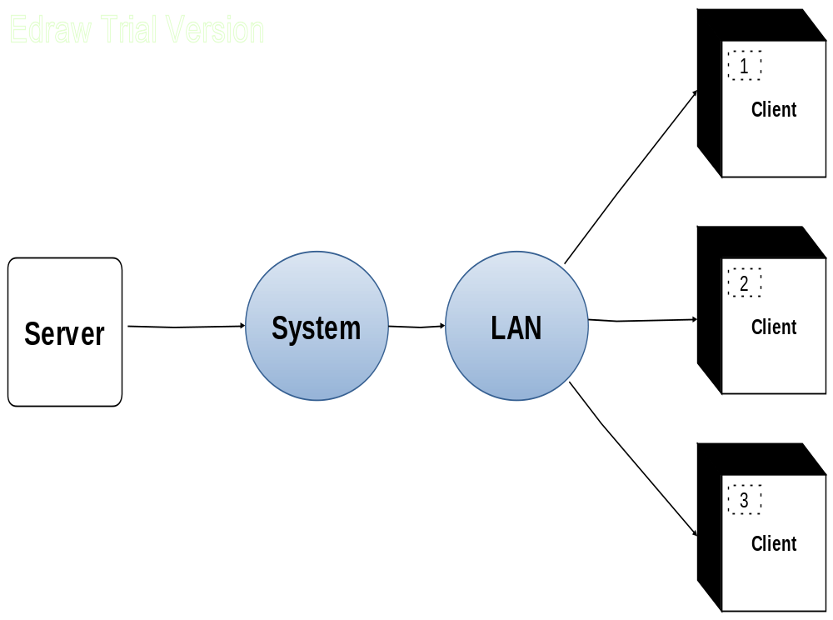

Level 1: Data Flow Diagrams:-

Servers have NEMS
Search for clients
Clients System
Select IP
Perform task
Connection problem
Server research
Task accomplished

Level 2: Data Flow Diagrams:-

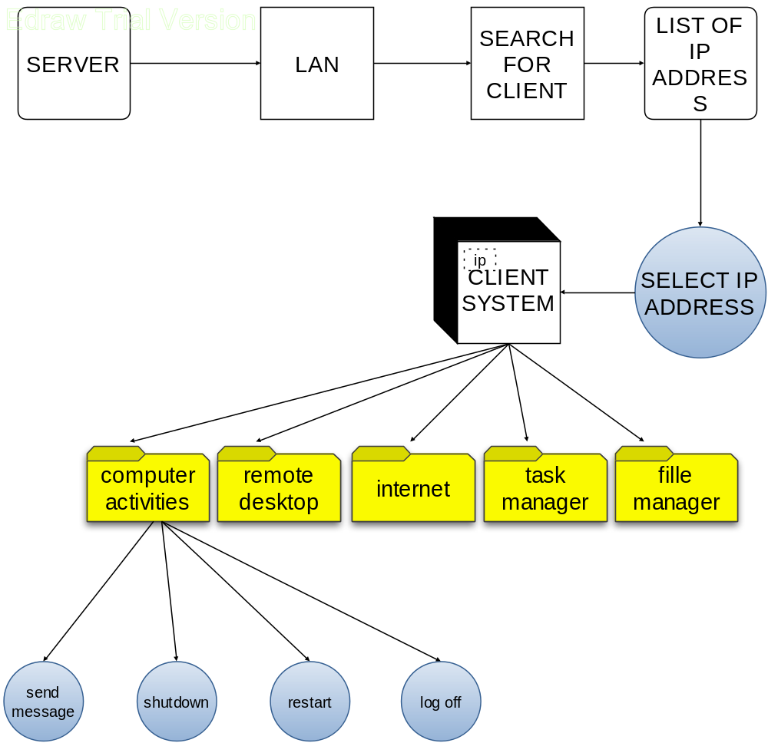

Coding

Software’s used
- Java(jdk1.6)
- Microsoft Window XP
- EditJavaPro(editor)
- Rational Rose
- Microsoft Office

Hardware specification
- Pentium II 330 MHz or Faster Processor.
- 128s MB Ram.
- Any Version of windows as an operating system with Internet Explorer.
- 1 GB of Hard disk space.
- Keyboard.
- Mouse
- LAN Card
- Wires and connectors

Programming language

- SUN java(jdk1.6)

Platform

Network and Employee Monitoring System required any system with Window XP and Java base.

Components/Tools:-

Modem, LAN card, wires (coaxial)

Coding style followed:-

Basic java programming

FEASIBILITY STUDY

The Feasibility study is the major factor that contributes to the analysis of the software. It is carried out to determine possibility of either improving the existing software or developing completely new software. It is use to evaluate the cost & benefits of requested software. The decision of the system analyst, whether to design a new software or not, depends on the feasibility study.

- Economic Feasibility:
This is concerned with the cost incurred for the development & implementation of software. The maintenance of the software is derived from it the cost involved is that of coding, implementation of software; hence the software is economically feasible.

- Technical Feasibility:
Requirement is the Pentium machine. The hardware and software needed for design and implementation of software is already available, the system is technically feasible. This deter mines whether the work for the project can be done with current requirement & existing software. If new techniques are required then what is the probability that can be developed. The required software for the designing is available therefore the software is technically feasible.

- Operational Feasibility:
The main user of software will be people, doing the present clerical job. The sort description of the software would be enough to operate the software friendly. Also they won’t find it difficult to migrate to the new software. Hence the software is operationally feasible. It determines whether the software will be used or not, if it is developed and implemented and performance. What new material, methods, algorithms or process are required, And what is their development risk? How will these technology issues affect cost?
The tools available for technical analysis are derived from mathematical modeling and optimization techniques, probability and statistics, queuing theory, and control theory - to name a few. It is important to note, how that analytical evaluation is not always possible. Modeling is an effective mechanism for technical analysis of computer – based systems.

TESTING

Here in this project we are going to apply two types of test cases as follows:
1. Back box testing
2. White box testing

White Box Testing:
White box testing sometimes called as glass box testing. Using white box testing methods, we can derive test cases that are

(1) All independent paths within a module have been exercised at
Last once.
(2)Exercise all logical decisions on their true and false sides.
(3) Execute all the loops at their boundaries and within their
Operational bounds.
(4) Exercise internal data structure to assure their validity.

No. | Step | Expected result | Actual result | Result
1 | Test loops in source code | Loop should be terminated when condition get mismatch | Loop get terminated | pass
2 | Test logical decisions | If else statement get executed properly | Generate desirable result that take system in expected mode | Pass
3 | Test internal data structure | Test type and size of different data types. | Data structure is properly handled | Pass

Black Box Testing:

Black box testing focuses on functional requirements of the software. Black box testing in fact derives sets of input conditions that will fully exercise all functional requirements for a program.

No. | Step | Expected result | Actual result | Result
1 | Test incorrect and missing function | All function should be consistent and declared | Duplicate function name but get accessed for different forms | Fail
2 | Interface error | Server should have access every time. | Connection gets disconnected. So no more access. | Fail
3 | Interface error | User should have access every time | Communication Success so get access. | Pass
4 | Performance error | Application should display all forms on Server screen | All forms are displayed on screen | Pass
5 | Initialization and termination error | Application should get exit by using exit option in menu | Application not get exit on some os.Server get switch off. | Fail

Unit Testing:

Unit testing focuses verification efforts on smallest unit of software design the module. Using procedural design description as a guide, import control paths are tested to uncover errors within the boundary of modules. The relative complexity of tests and uncovered errors is limited by the constrained scope established for unit testing. The unit test is generally white box oriented and step can be conducted in parallel for multiple modules.

No. | Step | Expected result | Actual result | Result
1 | Test IP address filed in user registration | IP field is blank | Error message get displayed” Enter IP address field please...” | Pass
2 | Test Server IP | User entered wrong IP | Server id is not unique ,system gives error ”Server IP not available” | Pass

Validation testing:

Validation can be defined in many ways. But the simple definition is that validation succeeds when software function in a manner that can reasonably expected by customer.

Validation and criteria:

Software validation is achieved through a series of black box tests that demonstrate conformity with requirements. After each validation and case has been conducted, one of two possible conditions exists.
1) The function or performance characteristics conform to
specification and are accepted.
2) A deviation from specification is uncovered and deficiency is listed.

Integration Testing:

After the modules were ready & tested they were integrated according to their functionality .A Bottom-up approach for integrating the various modules was followed.

System Testing:

System testing is actually a series of different tests whose primary purpose is to fully exercise the computer based system. System testing can be performed by various ways:
Recovery Testing:

Many computer based systems must recover from faults & resume processing within a prespecified time .In some cases, a system must be fault tolerant; that is processing faults must not cause overall system function to cease.

Security Testing:

Security testing verifies that protection mechanisms built into a system will, in fact, protect it from improper penetration.

Stress Testing:

Stress tests are designed to confront programs with abnormal situations. Stress testing executes a system in a manner that demands resources in abnormal quantity, frequency, or volume

Performance Testing:-

Performance testing is designed to test the run-time performance of software within the context of an integrated system. Performance testing occurs thought all steps in the testing process.

Configuration Management Plan

First Iteration:

Customer wants only to the take the clients ID and wants to performed the basic action like login, logoff, studdown, restart, etc.

Second Iteration:

After the study of previous systems we have added the new tasks with update to ours software.

Third Iteration:

Finally we have added the all configuration like as follows:-

Software Quality Assurance Plan

In this Report we can declare the cost of the project, and time.

- Learning Cost of Software: 2000/-

- Time duration:

Sr.No | Duration | Module
1 | 2 Weeks | Communication  Requirement gathering
2 | 2Weeks | Planning  Estimation  Schedule
3 | 4Weeks | Analysis and Design
4 | 6Weeks | Code
5 | 2Weeks | Test
Total | 16Weeks

- Total Cost:4000/-

CONCLUSION

- With the help of this project we can track the client system through server on a LAN.

- With the help of this project we can observes the client action & activity without these permission or authentication

- We would like to say that the system developed is flexible and can be used by anyone who is familiar with the basic mobile phone operations.

- All the objectives are that had been character out in the initial phases were achieved successfully.

- From the user’s point of view it satisfies all their requirements.

References

BOOKS:

- Software Engineering by Roger Pressman, TMH publication.

- The Unified Modeling Language User Guide by Grady Booch, James Rum Baugh, Ivar Jacobson, Pearson Education Publication.

- Herbert Schildt-Java2 the Complete Reference.

- JAVA2 Black Book.

MAGAZINES:

- Programming Magazines
- Design Magazines

WEB SITES:

- www.vi-labs.com
- www.chipsillicon.com
- www.amzon.com
- www.google.co.in
- www.codeproject.com

